Plate Tectonics
- How do the plates move?
- ___________________________: Driving force behind plate movements caused by the uneven heating of mantle fluids by the Earth’s interior.

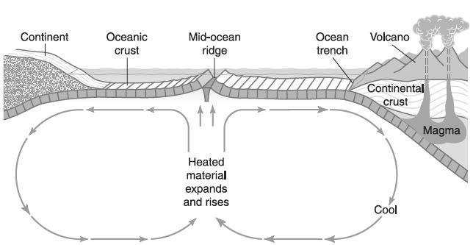

- What are the different ways plates interact?
  - ______________plate boundaries: 2 plates are moving away from one another due to rising convection currents
  - ______________plate boundary: 2 plates are moving towards each other due to sinking convection currents.
  - ______________plate boundary: 2 plates are sliding past one another

  - See ESRT page 12 – Global Tectonic Activity of the Last One Million Years.

